**Culinary competition**



**Instructor**

Prof. Ramsha Khalid

**Submitted by:**

Areej Zainab(2025-CS-271)

Aqsa Munir(2025-CS-280)

Ayesha Sarwar(2025-CS-281)

Soaiba Muzahir(2025-CS-291)

Tooba Umair(2025-CS-296)

**DEPARTMENT OF COMPUTER SCIENCE**

University of Engineering and Technology, Lahore

**Contents**

**Summary** 3

**Project Objectives and Scope** 3

**Site Structure and Navigation** 3

**Home Page** 3

**About Page** 4

**Rules Page** 6

**Registration Page** 7

**Contact Page** 8

**Design Choices** 10

**Assets Used** 10

**How to Run and Publish the Website** 10

**Reflection** 10

**Implementation and Improvement Plan** 11

**Insight Data:** 11

**1.** **Age Distribution** 11

**2.** **High-scoring Graph** 12

**3.** **Competition Score Distribution** 12

**Brochure** 13

# **Summary**

The Culinary Competition 2025 website is a static multi-page website developed to promote and support a food-based competitive event in a professional and visually appealing manner. The main purpose of this website is to provide complete, clear, and well-structured information about the culinary competition so that participants and visitors can easily understand the event details. The website serves as an online platform where students, home cooks, and culinary professionals can learn about the competition’s objectives, rules, registration process, and overall theme.

The website is designed using HTML and CSS, focusing entirely on front-end development. Special attention has been given to simplicity, consistency, and user-friendly navigation to ensure a positive user experience. The website includes multiple pages such as Home, About, Rules, Gallery, Registration, and Contact, each designed to serve a specific purpose. The Gallery page enhances visual appeal by displaying food-related images, while the Registration page provides a simple form for participant details.

Overall, the Culinary Competition 2025 website acts as an informative and promotional tool that supports the successful organization of the event. It reflects creativity, professionalism, and effective web design principles while encouraging participation and engagement.

# **Project Objectives and Scope**

The main objective of this project is to design and develop a professional website for a culinary competition. The website aims to clearly present all essential information related to the event, including its purpose, rules, and registration process. Another important objective is to create an attractive design that reflects food culture and creativity while remaining simple and easy to navigate.

The scope of this project is limited to front-end development only. The website is static and does not include backend programming or database connectivity. The registration form is designed for demonstration purposes and does not store user data. The website is purely informational and promotional in nature.

# **Site Structure and Navigation**

The website follows a multi-page structure with a navigation bar available on all pages. This allows users to move easily between different sections of the website.

**Home Page**The Home Page is the main entry point of the Culinary Competition website and creates the first impression for visitors. It clearly introduces the name and theme of the competition in an attractive and engaging way. Food-related colors and visuals are used to represent creativity, passion, and excitement for cooking. The layout of the page is simple and well organized, which makes the content easy to read and understand. A navigation bar is provided to help users move smoothly to other pages of the website. This page welcomes users and gives a clear overview of the culinary competition at a glance. Overall, the Home Page guides visitors and sets the tone and direction for the entire website.

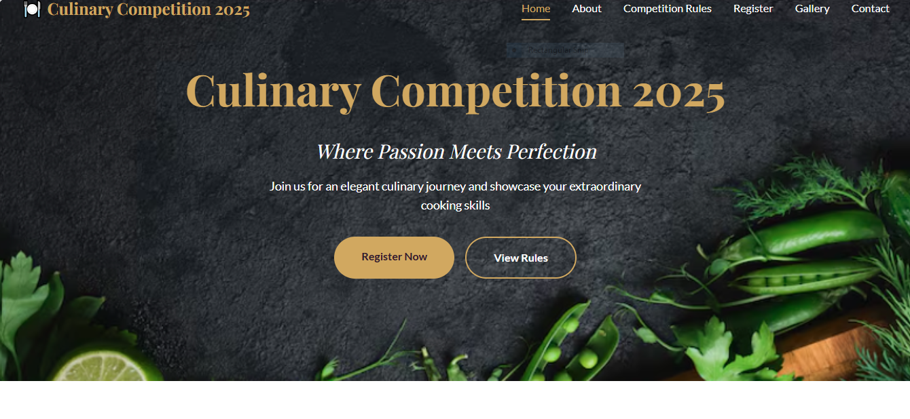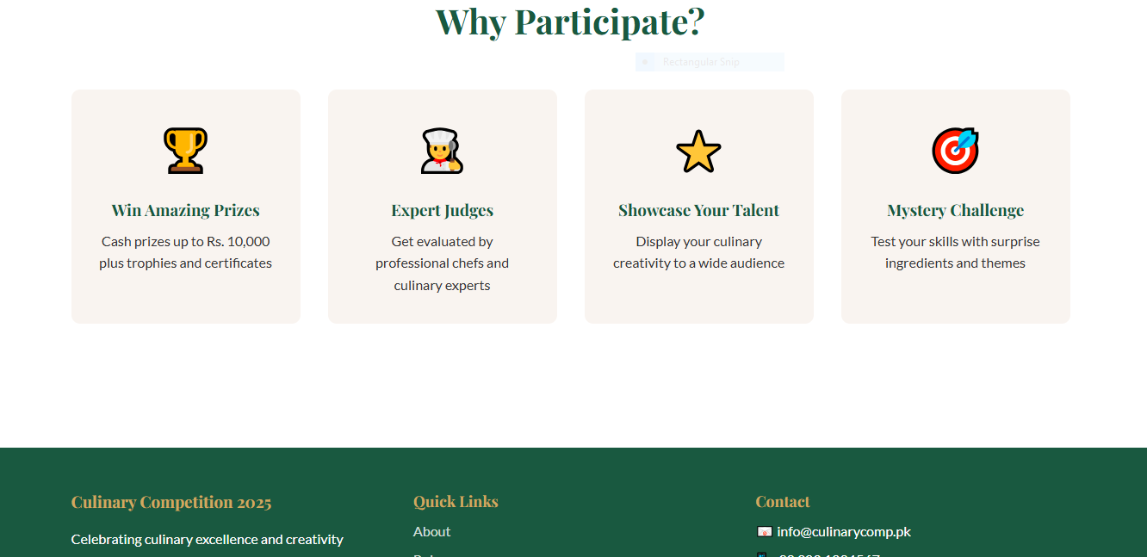

**About Page**

The About Page of the Culinary Competition website serves as an introduction to the event, providing visitors with a clear understanding of its purpose, background, and objectives. It explains why the competition was organized, what it aims to achieve, and the values it promotes. By emphasizing creativity, innovation, and passion in cooking, this page helps users recognize the importance of participating and engaging with the event. The content is presented in simple, easy-to-understand language, ensuring that it is accessible to everyone, from beginners to experienced chefs. It shares the story behind the competition, including its origin, goals, and vision, helping users feel connected and inspired. By clearly communicating the mission of the event, the About Page builds trust and credibility, showing that the competition is thoughtfully organized and meaningful.

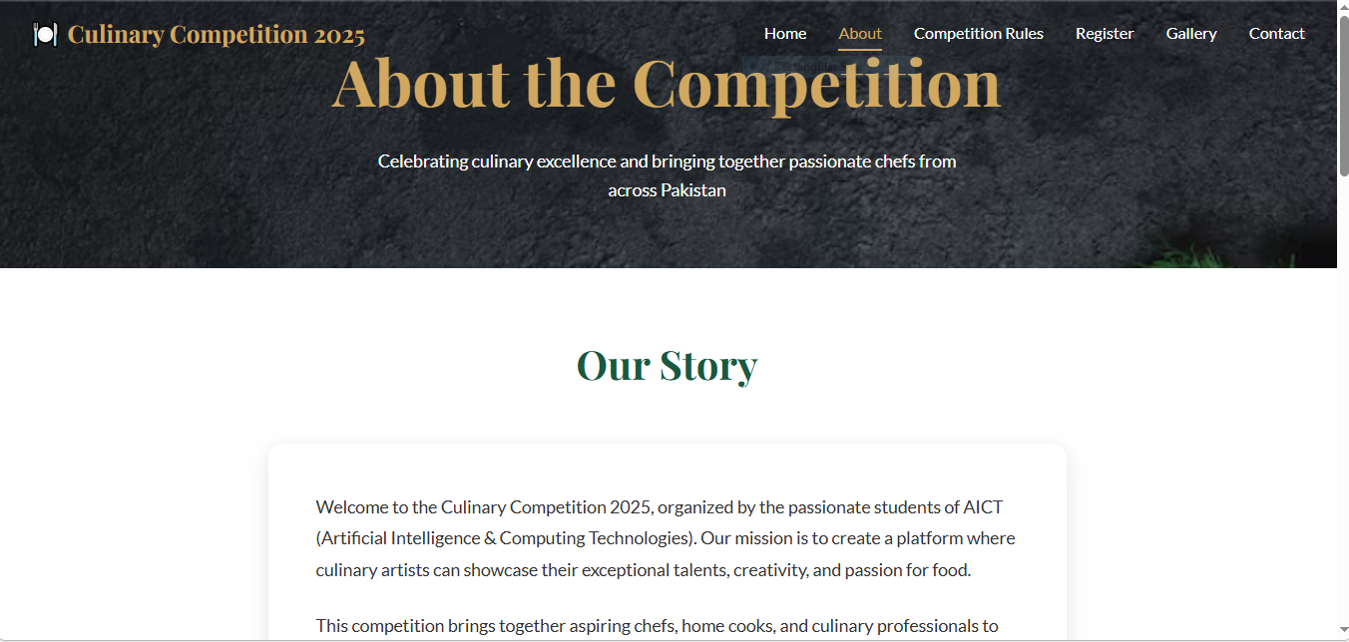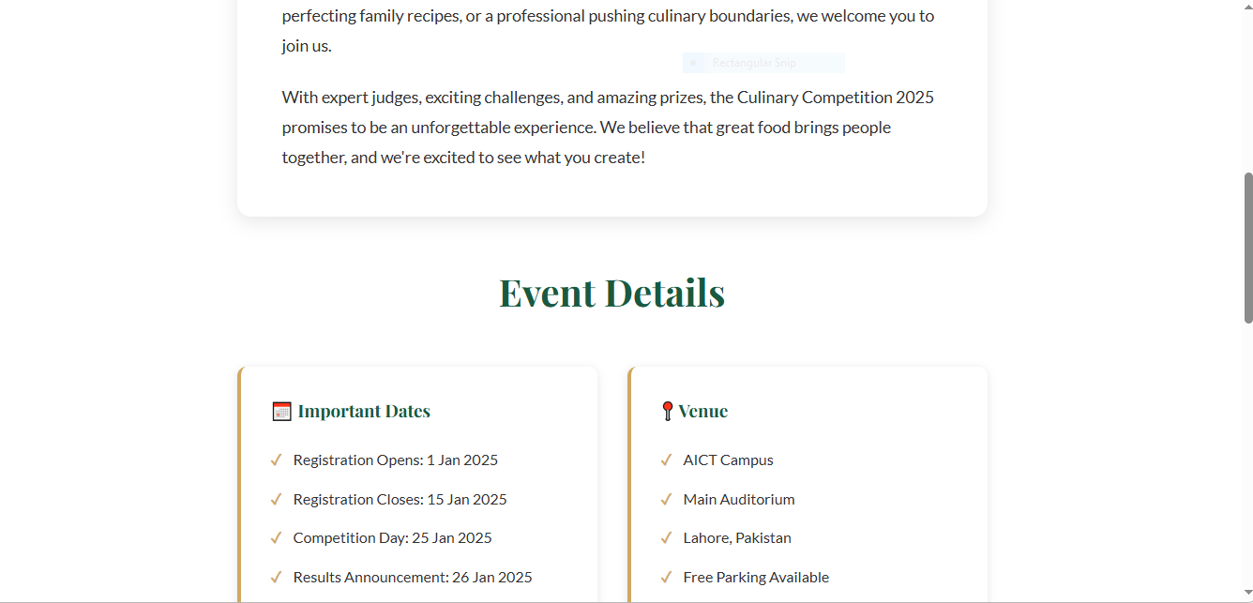

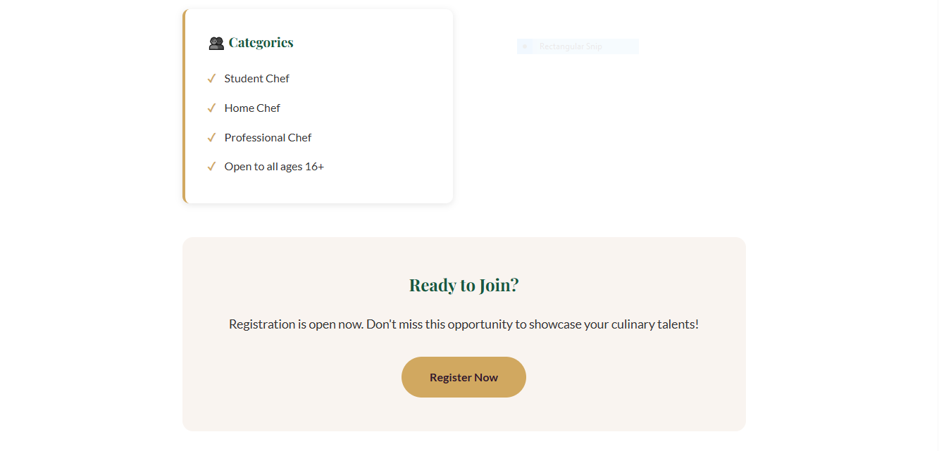

**Rules Page**The Rules Page of the website clearly outlines all the guidelines and regulations that participants must follow during the competition, ensuring fairness, transparency, and smooth management of the event. By providing detailed instructions, it helps participants prepare properly and avoid misunderstandings, promoting a disciplined and professional environment. *(Insert Rules Page Screenshot Here)* Meanwhile, the **Gallery Page** adds an engaging visual element by showcasing a variety of mouth-watering food images, including biryani, butter chicken, seekh kebabs, and delectable desserts. These visuals not only make the website more attractive but also inspire creativity and excitement among participants and visitors alike.

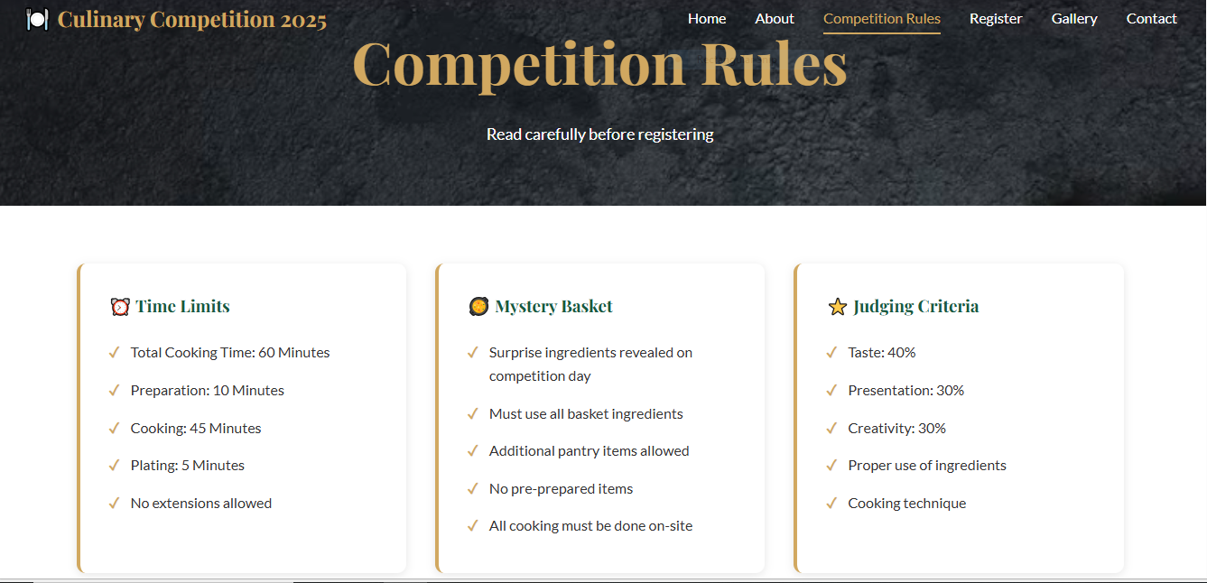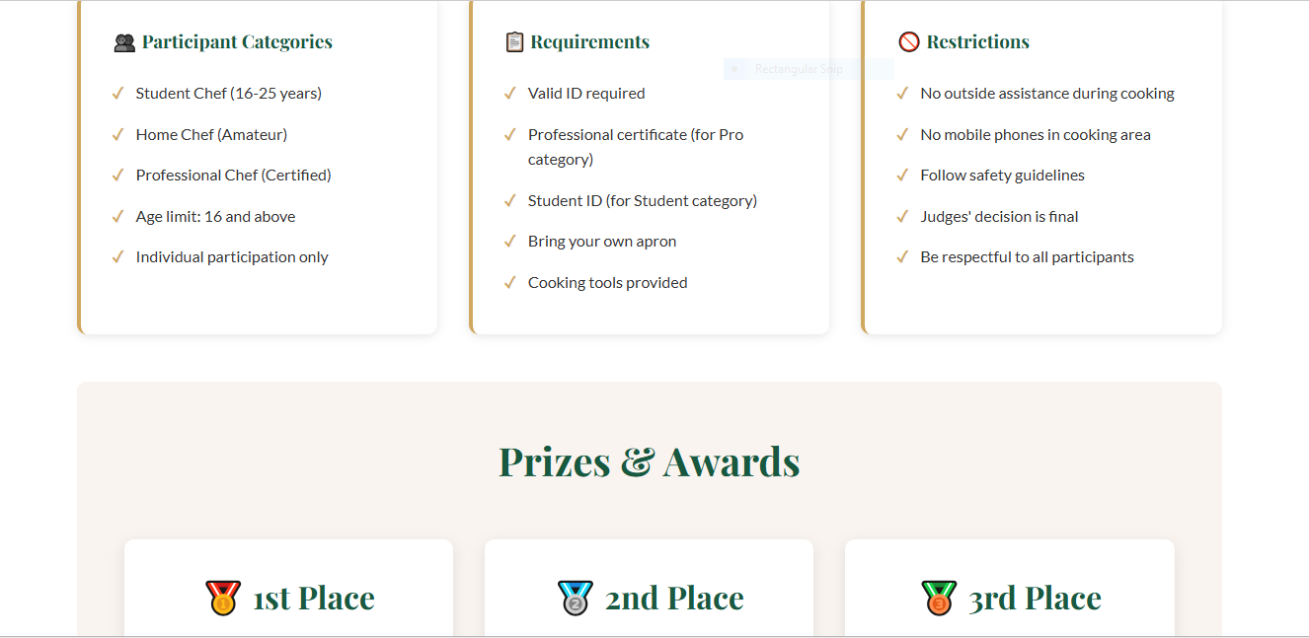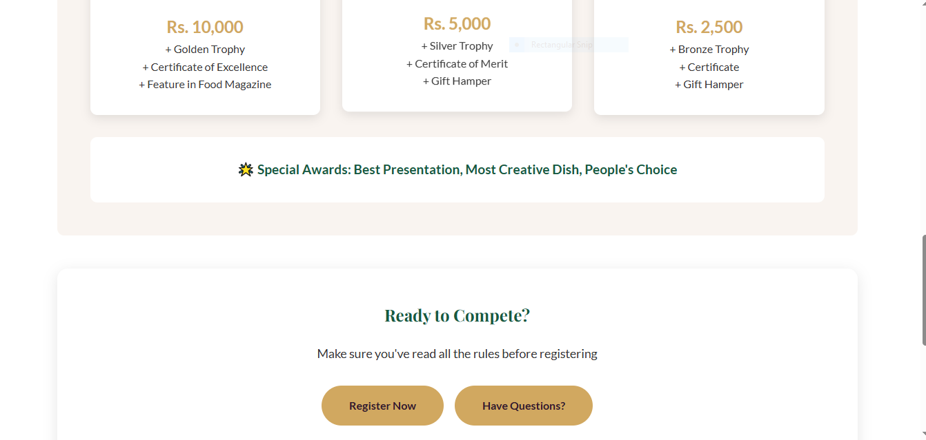

**Registration Page**The Registration Page allows participants to sign up for the competition. It contains a simple form to collect basic user information with clear and properly labeled fields. Clear labels make the form easy to fill and understand for all users. This page encourages users to participate in the event by providing a smooth registration process. The form layout is clean and well organized, which helps users’ complete registration without confusion. The page ensures a positive user experience by minimizing effort and saving time. The design focuses on simplicity and user friendliness. Overall, the Registration Page supports the participation process effectively.  
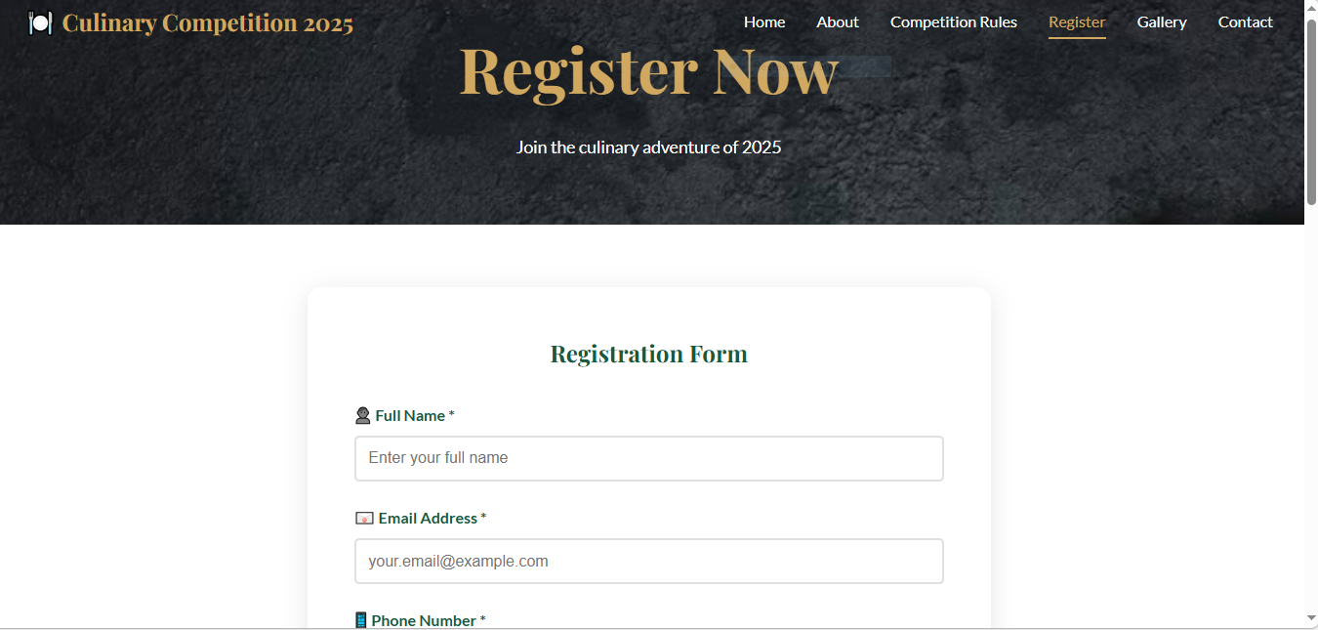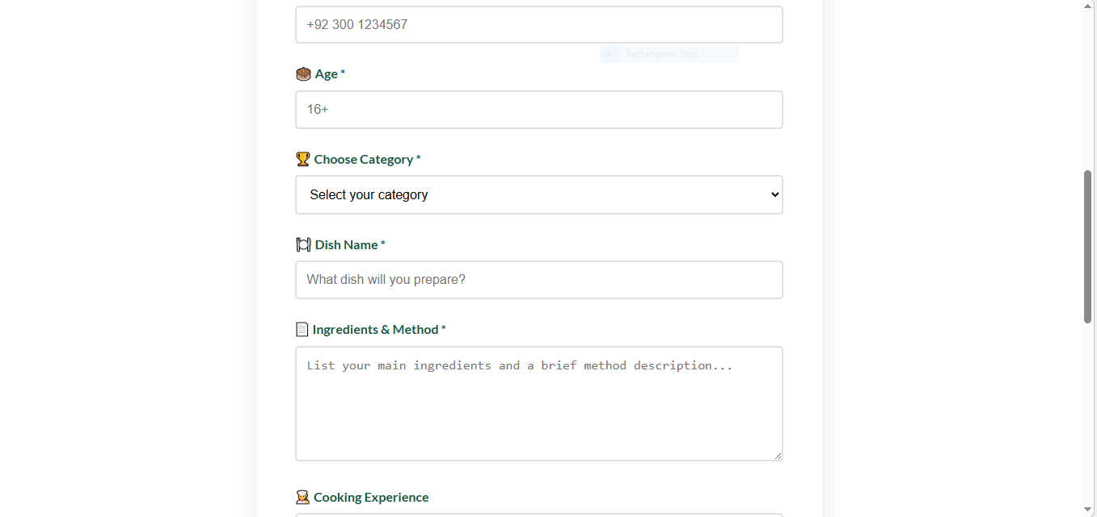

**Contact Page**The Contact Page provides contact details for users who need assistance or further information. It helps visitors communicate with the event organizers easily through clear and accessible contact information. This page improves the trust and reliability of the website by offering direct communication options. The layout is simple, clear, and easy to understand for all users. It supports user queries, guidance, and feedback related to the event. This page ensures that users feel supported and confident while using the website. Overall, the Contact Page completes the website structure effectively.  
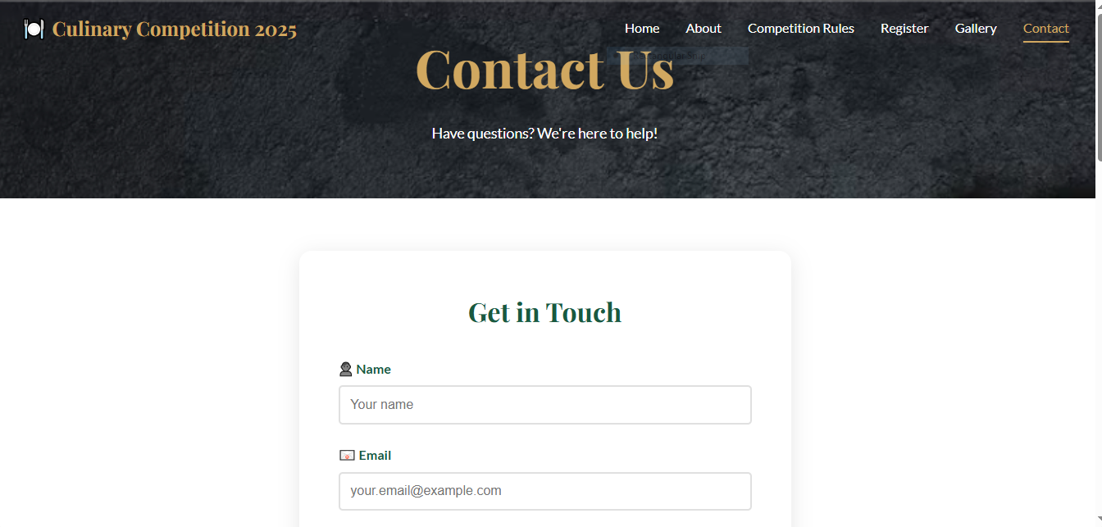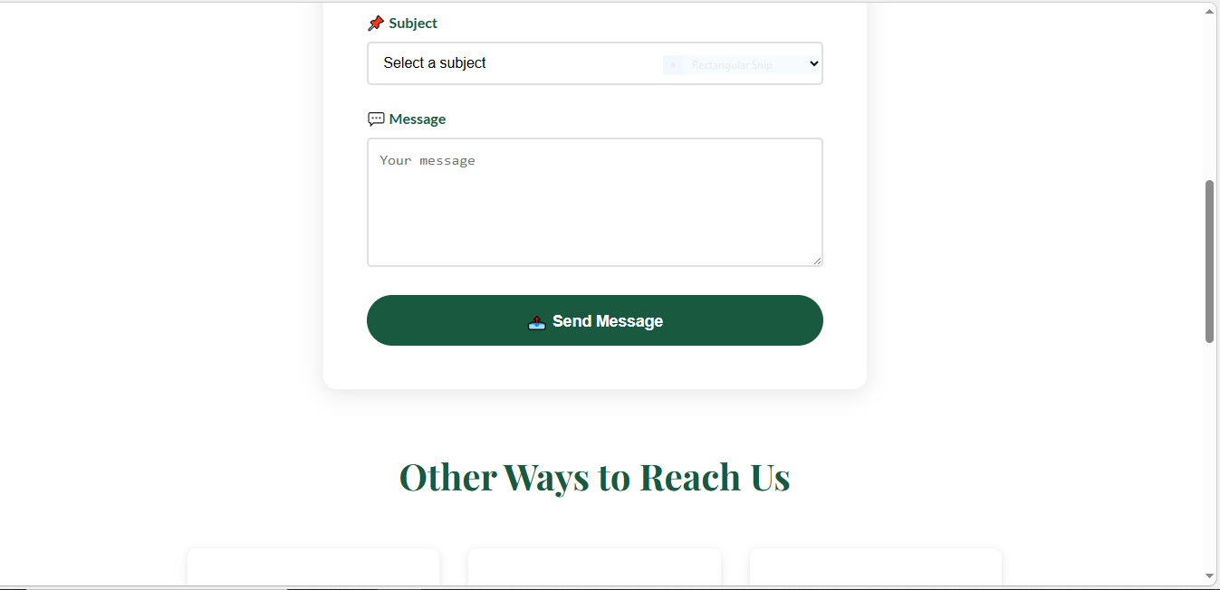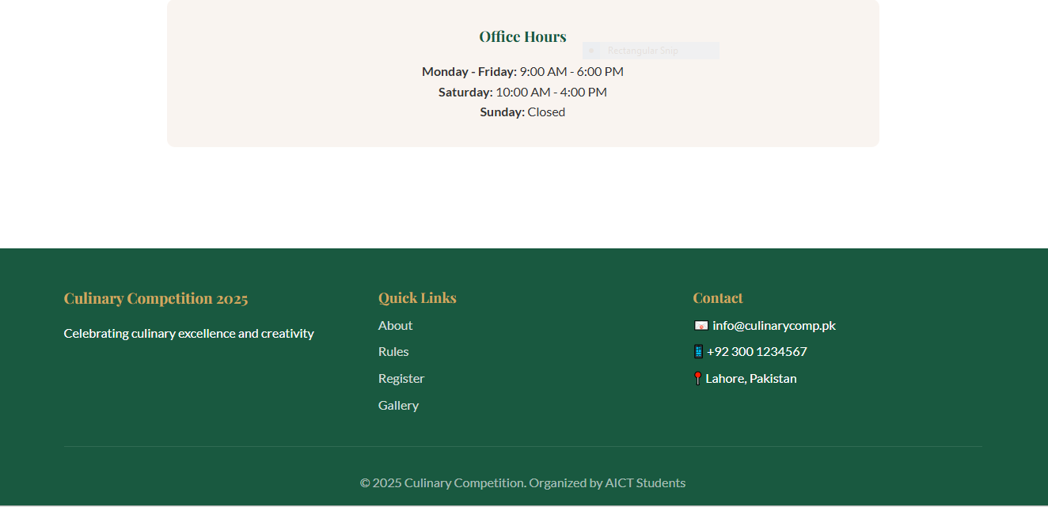

# **Design Choices**

The website uses warm and attractive colors to represent food, creativity, and excitement. Simple and readable fonts are chosen to improve user experience. A consistent layout is maintained across all pages with a navigation bar at the top. The design focuses on clarity, simplicity, and visual balance.

# **Assets Used**

The project uses food images in PNG format, including biryani, butter chicken, seekh kebab, and desserts. HTML files are used for structure, while a CSS file is used for styling and layout. Background images are also used to enhance the visual appearance of the website.

# **How to Run and Publish the Website**

To run the website locally, open the project folder and double-click on the index.html file. The website will open in a web browser.

To publish the website online, upload all project files to GitHub Pages or any web hosting service, ensuring that the folder structure remains unchanged.

# **Reflection**

This project helped me understand the basics of front-end web development using HTML and CSS. I learned how to create and link multiple web pages, apply consistent styling, and manage images effectively. The project improved my confidence in designing simple and professional websites.

# **Implementation and Improvement Plan**

In the future, this website can be improved by adding backend functionality and database integration to store registration data. Form validation can be added to ensure correct input. The website can also be made fully responsive for mobile devices, and interactive features can be included to enhance user engagement.

# **Insight Data:**

## **Age Distribution**

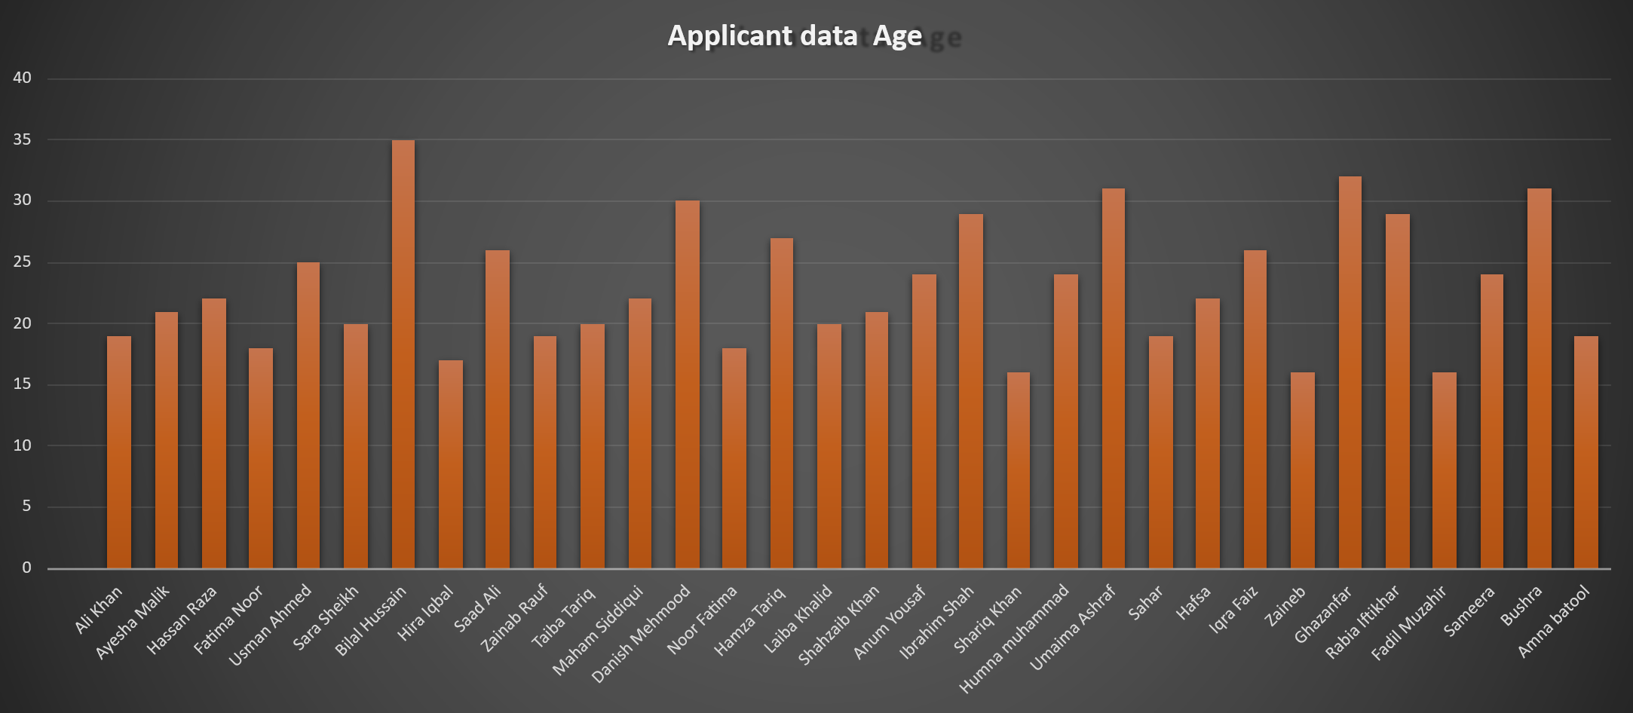

**Figure 1:** Bar chart showing age distribution of registered candidates.

This bar chart presents the ages of applicants, with each bar corresponding to an individual. The data shows a clear concentration of applicants in the young adult range, mainly between 18 and 30 years old, indicating a relatively youthful group. A small number of applicants fall below 18 or above 30, adding some variation but not significantly changing the overall age distribution.

## **High-scoring Graph**

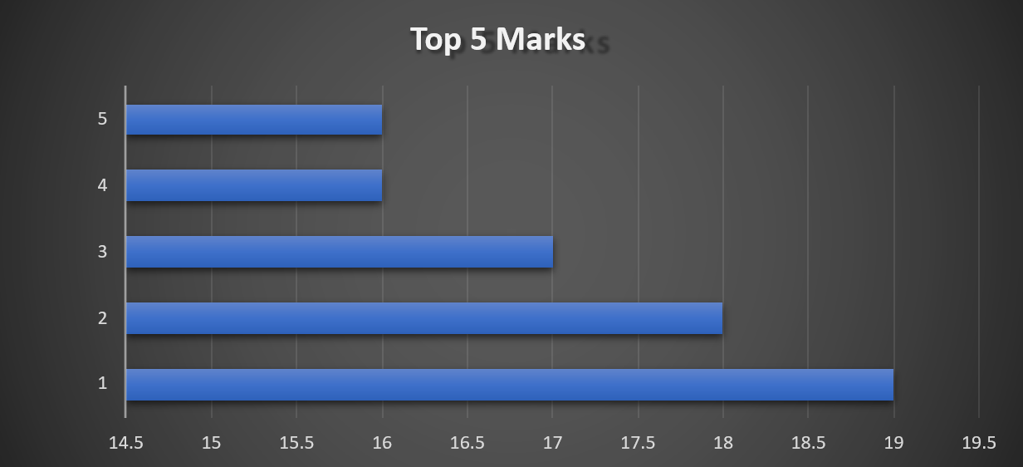

This graph shows the **top five marks**, ranked from highest to lowest. The longest bar represents the highest mark (around 19), while the remaining marks gradually decrease to about 16. The chart highlights a clear difference between the top scorer and the others, with a steady decline across the remaining top five results.

## **Competition Score Distribution**

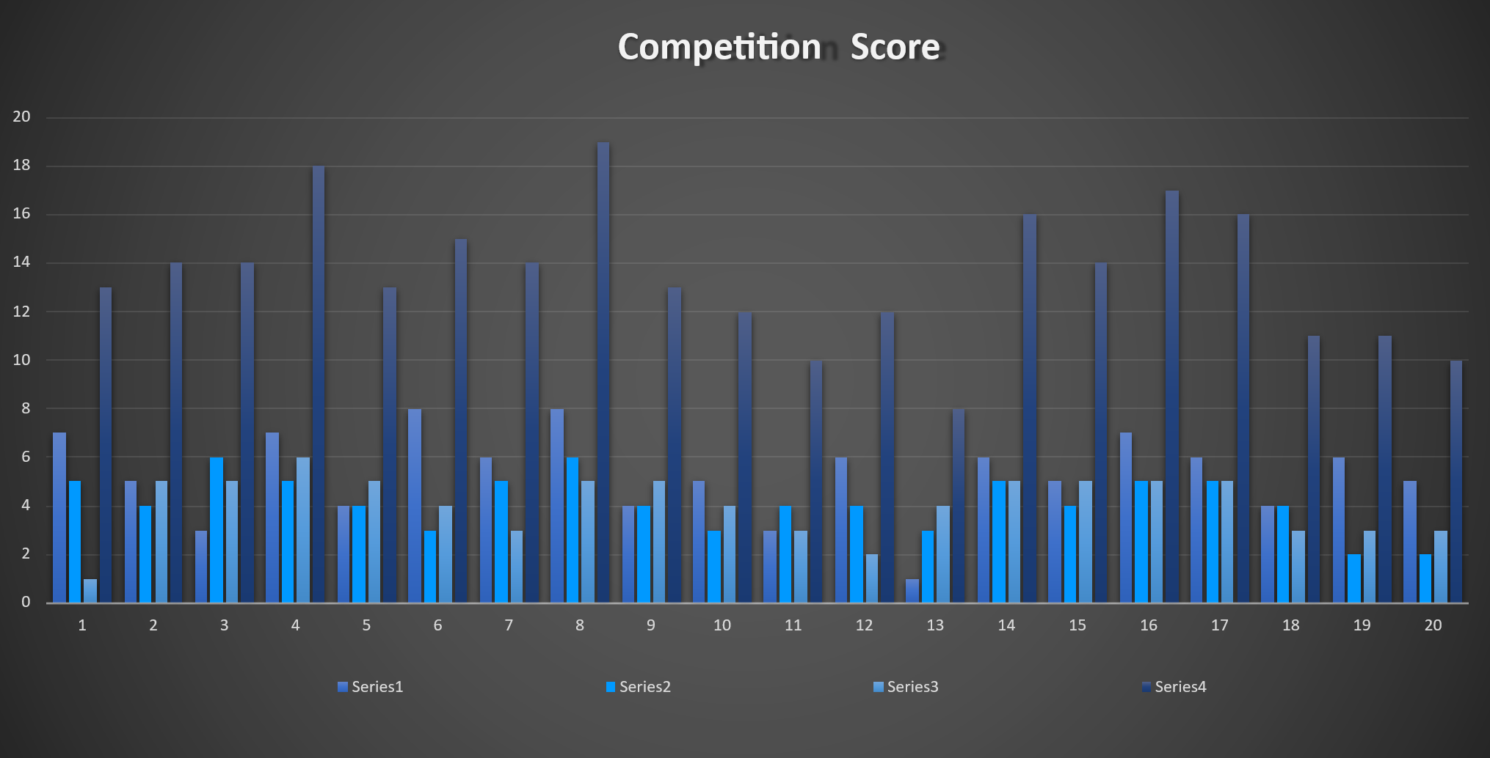

This graph illustrates **competition scores** across 20 participants using four different series. Each group shows variation in performance, with some participants scoring consistently higher than others across the series. Overall, the chart highlights differences in competitiveness, showing that while some scores peak around the mid-to-high range, others remain relatively low, indicating varied performance levels among participants.

# **Brochure**

